# Welcome to MED-Reminder

In this document we will walk you through how to use the system. Please note for now there is no GUI to interact with this is a CMD/ terminal application.

1. You will need a python inturpenter

*We recommend going to <https://www.python.org/downloads/> if you are on a windows machine

(for advanced users you can run this in a IDE setting as well)

*If you are on a macos machine <https://brew.sh/> you will need to install homebrew.

After that then download and install <https://www.python.org/downloads>

1. So now you hopefully have installed python, (and home brew for apple users), and have your CMD or terminal ready to take commands.

* using the Screenshot might help out for reference it’s the first picture on the screenshots page

*if youre not into screenshots we willbreak it down for you

1. Using the cd command navigate to the correct file folder ( google might be your friend)
2. After you get to the right folder type the command python3 meds.py for the medreminder program
3. Press enter and watch MED-REMINDER roar to life

---- The MED-REMINDER system will automatically create the files needed to run the program ----

**\\ TO CHANGE THE MED LIST PLEASE TYPE BUG IN THE MEDREMINDER SYSTEM TO GET IN TOUCH WITH US SO THAT WE CAN ADJUST THE LIST OF MEDICATION TO YOUR SPECFIC NEEDS //**

# Screenshots

If you are unfimilar with the language we’ll break it down. Cd is simply moving around to different folders located in the system.

When you get ready to run the MED-REMINDER program you’ll need to format the launch the command like ( python3 meds.py)

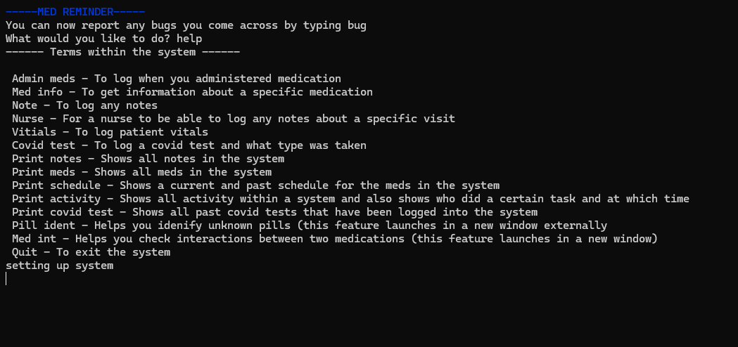

After your up and running you can type “help” and as you can see from the picture above we give you a list of all the commands in the system as well as what each command does.